Automated Irrigation System

# Y Chaitanya Sundar Jose Ch.en.u4cys21095,

Student, Dept. of Computer Science and Engineering

Amrita School of Engineering Chennai,

TamilNadu, India

***Abstract:*** *Watering is habitual practice that in some operations produced during your whole life experiences, such as farming or gardening. The process must be carried out since no matter how the weather is, for example, it is either hot and dry or cloudy and wet. In addition, in either of the two examples, you desire some water quantity to reach your plants. Watering systems are currently in place to ensure that plants are watered when they require it. However, the process of this manual labor entails two vital concerns: when and how much to give for water. To replace manual activities and pressure the gardener the work of this machine has been created on automatic plant watering.*being worried about absent or forgetfulness. For the garden or agricultural field, adding automated plant watering system will make all the plants adept to their full potential and at the same time conserve water. Whether using sprinklers drip emitters, or a composite of both, the system is an excellent fit for every plant in the yard. Sprinkler systems, pipes, and nozzles are the materials required to induce automatic plant watering systems. In our paper, we used ATmega328 microcontroller, which is programmed to detect moisture level of plants at some particular time and if moisture content is lower than some specified threshold which is based on known values according to water need of that particular plants and then it supplies required amount of water to plants till it reaches that threshold. Generally, plants need to be watered twice a day, morning and evening. Thus, the microcontroller is programmed to water plants two times per day. System is designed in such a way that it reports its current state as well as remind the user to add water to the tank. All this notifications are made through mobile application. We hope that through this prototype we all can enjoy having plants, without being worried about absent or forgetfulness.

***Keywords— Farming, watering, automatic system, sprinkler systems.***

1. INTRODUCTION

We all know that plants are very beneficial to all human beings in many aspects. Plants helps in keeping the environment healthy by cleaning air naturally and producing oxygen. Many people love to have plants in their backyard. But due to civilization and insufficiency of place many people used to grow plants in a mold or dirt, pot, and placed on the windowsill. This plant are dependent on conventional breeding - watering, and provide the right amount of sun to sustain life and growth. In busy schedule of day to day life, many time people forget to water

their plants and due to this plants suffers many disorders and ultimately died. In addition, the world's biggest problem in modem society is the shortage of water resources, agriculture is a demanding job to consume large amounts of water. It is very essential to utilize the water resources in proper way.

Thus, a system is required, to handle this task automatically. Automated plant watering system estimate and measure the existing plant and then supplies desired amount of water needed by that plant. It is minimizing the excess water use as well as keeping plants healthy.

1. PROJECT DESCRIPTION

During day to day activities many people often forget to water their plants and thus it becomes challenging for them to keep their plants healthy and alive. Also it is a challenge for farmers to maintain their fields and manage watering of plants during shortage of water. Based on the above background, we thought that it is necessary to implement the automated system which plants considering all the different aspects of home gardening system (for system based on household purpose) as well as larger landscape (for the system based on agricultural farms) and helps them to grow healthy. We also believe that technology can help people in cultivating plants, not just by automation but also through digital communications (such as to notify the user with the current status of the plant is important to note). Therefore, our project aims to implement a simple system, using automatic irrigation, watering a small potted plant or crop with minimal human intervention.

1. METHODOLOGY

This paper consists of two functional parts. They are the motor/pump and the moisture sensor. The Arduino IDE software is used to program the Arduino board. The moisture content of the soil is determined using a humidity sensor. Plants are supplied with water using a motor/pump system. The system is operating in accordance with the specified range of soil moisture and temperature, which is specifically set for the needs of various plants. The system's microcontroller, the ATmega328, is its brain. The input pin of the controller is linked to the temperature and humidity sensors. The output pin is connected to the servo motor and pump. When the soil moisture value falls below a certain threshold, the system automatically activates the water pump until the sensor reaches the threshold, at which point it shuts off. The user receives a report on all activity.

1. *Detecting Moisture Content:*
2. The soil moisture sensor will make this happen. An Arduino microcontroller board is linked to them. The Arduino IDE software is used to program the Arduino board. When a plant's soil moisture levels need to be increased, a humidity sensor detects this and notifies the Arduino.
3. *Automatic Watering To The Plant And User Notifications:*
4. The first buzzer will sound on Arduino to alert the user when it receives a logic high signal. In this project, the motor and general operation are controlled by an Arduino microcontroller coupled with a relay control switch. An external 9V battery connected to a microcontroller can power a motor.
5. COMPONENTS USED FOR IMPLEMENTATIO OF SYSTEM
   1. *Arduino Uno*

The Arduino Uno is a popular microcontroller board that's widely used in electronics projects. Here's some comprehensive information about the Arduino Uno:

1. Overview:

- The Arduino Uno is a microcontroller board based on the ATmega328P microcontroller chip.

- It comes with digital input/output pins, analog inputs, a USB connection for programming and power, a power jack, an ICSP header, and a reset button.

2. Microcontroller:

- The main microcontroller chip on the Arduino Uno is the ATmega328P, an 8-bit AVR microcontroller.

- It operates at a clock speed of 16 MHz and has 32KB of flash memory for storing programs, 2KB of SRAM, and 1KB of EEPROM.

3. Input/Output:

- Digital I/O Pins: The Uno has 14 digital input/output pins, of which 6 can be used as PWM outputs.

- Analog Inputs: There are 6 analog input pins labeled A0 through A5.

- Communication: The Uno has a USB connection for serial communication with a computer and an ICSP header for programming via an external programmer.

4. Power:

- The Arduino Uno can be powered via the USB connection from a computer or an external power supply.

- It can accept voltages from 7V to 20V through the power jack, but it typically operates at 5V.

5. Programming:

- The Arduino Uno is programmed using the Arduino Software (IDE), which is based on a simplified version of C++.

- Users can write programs (sketches) and upload them to the Uno via USB.

- The Uno has a built-in bootloader, which allows it to be programmed over USB without needing an external programmer.

6. Shields:

- The Arduino Uno is compatible with a wide range of expansion boards called shields.

- Shields can add functionality such as Ethernet, WiFi, Bluetooth, motor control, display, and more.

7. Applications:

- The Arduino Uno is used in a wide variety of projects including robotics, home automation, IoT (Internet of Things), prototyping, education, and DIY electronics.

- Its simplicity, ease of use, and large community support make it a popular choice for beginners and professionals alike.

8. Availability:

- The Arduino Uno is widely available for purchase from online retailers, electronics stores, and authorized Arduino distributors.

9. Documentation and Community:

- Arduino provides extensive documentation, tutorials, and examples for the Uno on their website.

- There's a large and active community of Arduino users who share projects, provide support, and contribute to the development of libraries and resources.

10. Versions:

- Over the years, there have been several revisions of the Arduino Uno, with minor improvements and changes to the board layout, but the basic functionality remains the same.

Overall, the Arduino Uno is a versatile and user-friendly platform for building and experimenting with electronics projects. Its simplicity, combined with a wide range of features and expansion possibilities, makes it a popular choice among hobbyists, educators, and professionals.

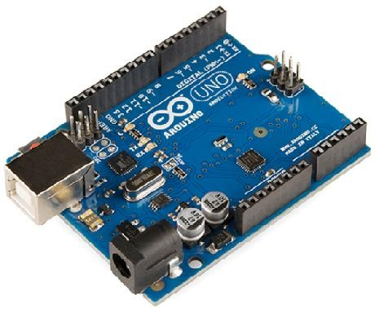

* 1. MOISTURE SENSOR

Soil moisture refers to the amount of water held in the soil, which is vital for plant growth and agricultural productivity. Monitoring soil moisture levels is crucial for optimizing irrigation practices, preventing overwatering or underwatering, and ensuring efficient water use. Here's some total information about soil moisture:

1. **Importance in Agriculture**: Soil moisture directly affects plant growth, nutrient uptake, and crop yield. Insufficient moisture can lead to wilting and reduced yield, while excessive moisture can cause root rot and other diseases.

2. **Measurement Methods**:

- **Gravimetric Method**: Involves weighing soil samples before and after drying to determine moisture content.

- **Tensiometers**: Measure soil moisture tension, which indicates the force required to extract water from the soil.

- **Time Domain Reflectometry (TDR)**: Measures soil moisture by sending electromagnetic pulses through the soil and analyzing the reflected signals.

- **Soil Moisture Sensors**: Utilize electrical resistance, capacitance, or frequency domain techniques to measure soil moisture levels directly.

3. **Factors Affecting Soil Moisture**:

- **Precipitation**: Rainfall replenishes soil moisture levels.

- **Evapotranspiration**: Loss of moisture from soil through evaporation and transpiration by plants.

- **Soil Type**: Different soil types have varying water-holding capacities.

- **Temperature**: Higher temperatures increase evaporation rates.

- **Slope and Drainage**: Sloped terrain and poor drainage can lead to water runoff.

4. **Importance in Environmental Monitoring**:

- Soil moisture influences weather patterns, hydrological cycles, and groundwater recharge.

- It plays a role in landslide prediction, drought monitoring, and ecosystem health assessment.

5. **Technological Advancements**:

- Remote sensing satellites provide large-scale soil moisture data, aiding in agricultural planning and water resource management.

- Internet of Things (IoT) devices and wireless sensor networks enable real-time monitoring of soil moisture at multiple locations.

- Data analytics and machine learning algorithms are used to analyze soil moisture data and optimize irrigation schedules.

6. **Challenges**:

- Spatial and temporal variability of soil moisture poses challenges in accurate measurement and prediction.

- Integration of soil moisture data with other environmental parameters for comprehensive analysis.

- Accessibility and affordability of soil moisture monitoring technologies, especially in developing regions.

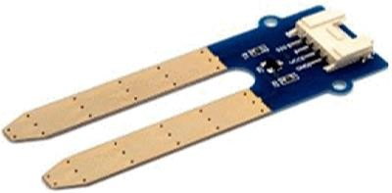

* 1. WATER PUMP

A DC motor is a type of electric motor that converts direct current (DC) electrical power into mechanical power. It is widely used in various applications such as industrial machinery, automotive systems, robotics, and home appliances. Here's a comprehensive overview of DC motors:

Components of a DC Motor:

1. **Stator**: The stationary part of the motor that contains coils of wire, which generate a magnetic field when an electric current flows through them.

2. **Rotor**: The rotating part of the motor that is connected to the output shaft. It interacts with the magnetic field produced by the stator to generate motion.

3. **Commutator**: A segmented metal ring that is attached to the rotor shaft. It reverses the direction of current flow in the rotor windings as the rotor turns, ensuring continuous rotation.

4. **Brushes**: Carbon brushes that make physical contact with the commutator segments and deliver electrical power to the rotor windings.

5. **Brush Holder**: A component that holds the brushes in place and allows them to maintain contact with the commutator.

6. **Shaft**: The output shaft of the motor, which transfers mechanical power to the load.

Working Principle:

- When a DC voltage is applied to the stator windings, it creates a magnetic field.

- This magnetic field interacts with the magnetic field produced by the rotor, causing the rotor to rotate.

- As the rotor turns, the commutator reverses the direction of current flow in the rotor windings, ensuring continuous rotation.

- The direction of rotation can be controlled by reversing the polarity of the applied voltage or by using external circuitry such as H-bridge configurations.

Types of DC Motors:

1. **Brushed DC Motors**: These motors use brushes and a commutator to transfer power to the rotor windings. They are simple and economical but require maintenance due to brush wear.

2. **Brushless DC Motors (BLDC)**: These motors use electronic commutation instead of brushes and commutators. They offer higher efficiency, lower maintenance, and better speed control but are more complex and expensive.

3. **Permanent Magnet DC Motors (PMDC)**: These motors have a permanent magnet stator and are commonly used in applications requiring high torque at low speeds.

4. **Series Wound DC Motors**: These motors have the stator and rotor windings connected in series. They provide high starting torque but limited speed control.

5. **Shunt Wound DC Motors**: These motors have the stator and rotor windings connected in parallel. They offer better speed control but lower starting torque compared to series wound motors.

Applications:

- DC motors are used in a wide range of applications including:

- Electric vehicles (EVs) and hybrid vehicles

- Industrial machinery such as conveyor belts and pumps

- Robotics and automation systems

- Home appliances like fans, blowers, and power tools

- Aerospace and defense systems

- Medical devices and equipment

Considerations:

- When selecting a DC motor for a specific application, factors such as torque, speed, power efficiency, size, and cost must be considered.

- Proper maintenance, including lubrication and brush replacement (for brushed motors), is essential to ensure optimal performance and longevity.

- Control methods such as pulse width modulation (PWM) are commonly used to regulate the speed of DC motors.

- Safety precautions should be observed, especially when working with high-power motors, to prevent electrical hazards and mechanical accidents.

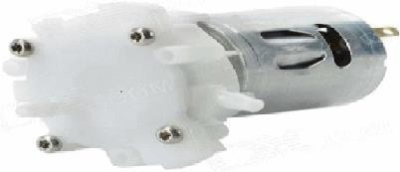

* 1. *The Relay Module*

Relay is an electrically operated switch. Many relays for switching solenoid mechanism mechanically operated, but can also be used for other principles of operation. Relays are widely used in early computers to telephones and perform logical operations.

* 1. *Arduino IDE Tool*

Arduino open-source environment, you can easily write code and upload it to the 110 board. It runs on Windows, Mac OS X and Linux. Environment is written in Java, and according to the processing, AVC-GCC, as well as other open source software.

* 1. LM35 Sensor

Overview:

Type: Analog Temperature Sensor

Output: Linear voltage output proportional to temperature

- Range: Typically operates from -55°C to 150°C

- Accuracy: ±0.5°C (at 25°C)

- Supply Voltage: Typically operates from 4V to 30V

- Package: TO-92, TO-220, or other similar packages

Key Features:

1. Linear Output: The output voltage of the LM35 sensor is linearly proportional to the temperature being measured, making it easy to interface with microcontrollers or analog circuits.

2. Calibrated: The LM35 sensor comes pre-calibrated from the factory, ensuring accurate temperature readings without the need for additional calibration.

3. Low-Cost: LM35 sensors are relatively inexpensive, making them suitable for various temperature sensing applications.

4. Low Power Consumption: Consumes very low power, making it suitable for battery-operated applications.

5. Wide Operating Voltage Range: Can operate within a wide range of supply voltages, providing flexibility in different circuit designs.

Pinout:

The LM35 sensor typically has three pins:

- VCC: Supply voltage pin (typically connected to +5V)

- OUT: Analog output pin (proportional to temperature)

- GND: Ground pin

Applications:

- Temperature monitoring and control systems

- Environmental monitoring systems

- Industrial automation

- Weather stations

- Automotive applications

- Consumer electronics (e.g., thermostats, HVAC systems)

Limitations:

- Limited temperature range compared to some other temperature sensors.

- Susceptible to noise and variations in supply voltage, which may require additional filtering or regulation circuitry.

* 1. Humidity Sensor

A humidity sensor is a device that measures the moisture content in the air. It's commonly used in various applications including weather monitoring, HVAC systems, agriculture, and industrial processes. Here's some information about humidity sensors:

Types of Humidity Sensors:

1. Capacitive Humidity Sensor: These sensors measure humidity by detecting changes in capacitance caused by changes in humidity.

2. **Resistive Humidity Sensors**: These sensors use a thin film of a moisture-absorbing material whose electrical resistance changes with humidity.

3. **Thermal Conductivity Humidity Sensors**: These sensors measure the change in thermal conductivity of air with humidity.

4. **Gravimetric Humidity Sensors**: These sensors measure humidity by the change in weight of a material as it absorbs moisture.

5. **Optical Humidity Sensors**: These sensors use light absorption or reflection properties of materials to measure humidity.

### Components and Working Principle:

- **Sensing Element**: This is the core component of the humidity sensor that interacts with the moisture in the air and produces a measurable output.

- **Signal Conditioning Circuitry**: This circuitry processes the signal from the sensing element and converts it into a usable form.

- **Output Interface**: The sensor typically provides an analog voltage, current, or digital output that can be read by microcontrollers or other devices.

### Applications:

1. **Weather Monitoring**: Humidity sensors are used in weather stations to measure and monitor humidity levels in the atmosphere.

2. HVAC Systems: In heating, ventilation, and air conditioning systems, humidity sensors help maintain optimal indoor air quality and comfort.

3. Agriculture: Humidity sensors are used in greenhouses and farms to monitor and control humidity levels for optimal plant growth.

4. Industrial Processes: In manufacturing and industrial processes, humidity sensors ensure proper environmental conditions for production and storage of goods.

5. Medical: In medical applications, humidity sensors are used in incubators, respiratory devices, and environmental chambers to control humidity levels for patient comfort and health.

Challenges and Considerations:

-Calibration: Humidity sensors require periodic calibration to ensure accuracy and reliability.

- Drift: Some humidity sensors may experience drift over time, leading to inaccurate measurements.

- Response Time: The response time of humidity sensors varies depending on the type and model, which may be critical for certain applications.

- Environmental Conditions: Factors such as temperature, pressure, and contaminants in the air can affect the performance of humidity sensors.

- Cost: The cost of humidity sensors varies depending on factors such as accuracy, range, and features.

* 1. Resistors

1. Resistance Value:

Resistors are passive two-terminal electronic components that impede the flow of electric current. Their primary function is to provide resistance to the flow of electrical current.

The resistance value of a resistor is measured in ohms (Ω). It determines how much the resistor opposes the flow of electric current.

The resistance value is typically indicated by color bands on the body of the resistor. Different color codes are used to represent different values.

2. Color Coding:

Resistors commonly use a color-coding system to denote their resistance values.

The color bands on the resistor indicate the significant digits, multiplier, and tolerance of the resistor.

The first two bands represent the significant digits, the third band represents the multiplier, and the fourth band represents the tolerance.

The tolerance band indicates the range within which the actual resistance may vary from the specified resistance value.

3. Power Rating:

The power rating of a resistor specifies the maximum amount of power it can dissipate without being damaged.

It is typically measured in watts (W) and is determined by the physical size and construction of the resistor.

Exceeding the power rating can lead to overheating and potentially damaging the resistor.

4. Types of Resistors:

There are various types of resistors available, each with its own characteristics and applications.

Some common types include carbon film resistors, metal film resistors, wirewound resistors, and variable resistors (potentiometers).

5. Applications:

Resistors are used in a wide range of electronic circuits and devices.

They are commonly used for voltage division, current limiting, signal conditioning, biasing, and impedance matching.

Resistors play a crucial role in controlling the behavior of electronic components and ensuring proper operation of circuits.

6. Series and Parallel Connection:

Resistors can be connected in series or parallel to achieve different resistance values and voltage/current characteristics.

In series connection, the total resistance is the sum of individual resistances.

In parallel connection, the total resistance is calculated using the reciprocal of the sum of the reciprocals of individual resistances.

7. Temperature Coefficient:

The resistance of a resistor may vary with temperature. The temperature coefficient specifies this variation.

It indicates the rate of change of resistance with temperature and is typically expressed in parts per million per degree Celsius (ppm/°C).

* 1. Potentiometer

A potentiometer, often abbreviated as "pot," is a three-terminal resistor with a sliding or rotating contact that forms an adjustable voltage divider. It's a widely used electronic component in various applications, including audio equipment, lighting controls, and instrumentation.

Here's a breakdown of the total information regarding potentiometers:

1. Construction:

Terminals: Potentiometers typically have three terminals: the input terminal (often called the "input" or "1"), the output terminal (often called the "wiper" or "2"), and the ground terminal (often called the "ground" or "3").

Resistance Element: The resistance element is the resistive material along which the wiper moves. It can be made of materials like carbon, cermet (ceramic-metal mixture), or conductive plastic.

Wiper: The wiper is the moving contact that slides or rotates along the resistance element, allowing the user to adjust the output voltage.

2. Types of Potentiometers:

Linear Potentiometer: The resistance varies linearly with the wiper's position, resulting in a linear relationship between the wiper position and the output voltage.

Logarithmic Potentiometer (Log Pot): Also known as audio taper potentiometers, they provide a logarithmic relationship between the wiper position and the output voltage, which is suitable for audio volume controls.

Multi-Turn Potentiometer: These potentiometers have multiple turns of the wiper shaft, allowing for finer adjustment and higher precision.

3. Applications:

Volume Control: Potentiometers are commonly used in audio equipment, such as amplifiers, radios, and mixers, for volume control.

Brightness Control: They are used in lighting controls to adjust the brightness of lamps or LEDs.

Instrumentation: Potentiometers are used in various measuring instruments and control systems for calibration and adjustment.

User Interfaces: They are used in user interfaces for adjusting settings in devices like appliances, vehicles, and industrial machinery.

4. Working Principle:

By adjusting the position of the wiper along the resistive element, the effective resistance between the input and output terminals changes.

This change in resistance results in a corresponding change in the voltage output across the output terminal and the ground terminal.

The output voltage is typically measured relative to the ground terminal.

5. Potentiometer Symbols:

Potentiometers are represented by various symbols in circuit diagrams, with different variations based on their type and usage. Common symbols include a resistor with an arrow indicating the adjustable wiper.

6. Characteristics:

Resistance Range: Potentiometers are available in a wide range of resistance values, from a few ohms to several megaohms.

Tolerance: The tolerance specifies the allowable deviation from the nominal resistance value.

Power Rating: Potentiometers are rated for the maximum power they can dissipate without overheating.

Lifetime: The lifetime of a potentiometer is an important characteristic, especially in applications where it undergoes frequent adjustments.

* 1. BJT

A BJT is a type of transistor that uses both electron and hole charge carriers. It's a three-layer semiconductor device consisting of p-type and n-type materials.

Structure:

BJT typically consists of three regions: emitter, base, and collector. There are two types of BJTs: NPN and PNP, based on the arrangement of semiconductor materials.

Operation:

In NPN BJTs, electrons flow from the emitter to the collector through the base when a small current is applied to the base-emitter junction. In PNP BJTs, holes flow in the opposite direction.

The base current controls the collector current in BJTs, making them useful for amplification and switching purposes.

Modes:

BJTs operate in three modes: Active, Cut-off, and Saturation.

Active mode: The transistor is conducting and acts as an amplifier.

Cut-off mode: The transistor is non-conducting.

Saturation mode: The transistor is fully conducting, acting like a closed switch.

Applications:

BJTs are widely used in analog circuits such as amplifiers, oscillators, and signal processing circuits.

They are also used in digital logic circuits and switching applications.

Advantages:

BJTs have high current gain.

They exhibit low noise performance.

They have fast switching speeds.

Disadvantages:

BJTs require more power compared to MOSFETs.

They are more susceptible to temperature variations.

Fabrication processes for BJTs are more complex compared to MOSFETs.

BJT Variants:

Darlington Pair: Two BJTs connected in cascade to provide high current gain.

Phototransistor: A BJT designed to respond to light, commonly used in optoelectronic applications.

Modern Trends:

Despite the widespread use of MOSFETs in modern integrated circuits, BJTs still find applications in high-frequency and high-power circuits.

* 1. Led Red

Color: Red LEDs emit red light, which typically has a wavelength in the range of approximately 620 to 750 nanometers.

Functionality: LEDs are semiconductor devices that emit light when an electric current passes through them. A red LED emits light in the red part of the visible spectrum when forward biased.

Applications: Red LEDs find applications in various fields including:

Indicator lights: They are commonly used as indicator lights in electronic devices, appliances, and control panels.

Signage and displays: Red LEDs are used in outdoor and indoor signage, traffic lights, and alphanumeric displays.

Automotive lighting: They are used in brake lights, tail lights, and turn signals in vehicles.

Decorative lighting: Red LEDs are used in decorative lighting applications such as holiday lights, stage lighting, and architectural lighting.

Efficiency: LED technology is known for its energy efficiency compared to traditional incandescent and fluorescent lighting. Red LEDs typically have high efficiency and long lifespans.

Safety: LED lights emit minimal heat compared to traditional light sources, reducing the risk of burns or fire hazards. However, it's essential to follow safety guidelines and specifications provided by manufacturers when using LEDs.

* 1. Led Green

Color: Green LEDs emit light with wavelengths typically ranging from around 495 nanometers (nm) to 570 nm, corresponding to the green portion of the spectrum.

Semiconductor Material: Green LEDs are typically made from semiconductor materials such as gallium nitride (GaN) or aluminum gallium indium phosphide (AlGaInP), depending on the specific technology used.

Energy Efficiency: LEDs in general, including green LEDs, are known for their energy efficiency. They require much less power compared to traditional lighting technologies like incandescent bulbs.

Applications: Green LEDs find applications in various fields including:

Indicator lights in electronic devices (e.g., power indicators, status indicators).

Lighting for displays and signage.

Automotive lighting.

Decorative lighting.

Plant growth lighting (in combination with other colors for indoor gardening).

Brightness and Intensity: The brightness and intensity of green LEDs can vary depending on factors such as the forward current passing through them and the design of the LED.

Durability and Lifespan: LEDs, including green LEDs, are known for their durability and long lifespan compared to traditional lighting sources. They are less susceptible to damage from shock or vibration and typically have a longer operational lifespan.

Environmental Impact: Green LEDs are generally considered environmentally friendly compared to traditional lighting sources due to their lower energy consumption and longer lifespan. However, like all electronic devices, they do have environmental considerations related to manufacturing processes and disposal.

1. PROPOSED METHODOLOGY
   1. Build System Relay

We create connections to the solid state relays, Arduino, and small fountain pump system, Arduino allows the pump open or close automatically. A striped cut through the inner tube of the pump segment insulated wire, only half. Install the new cut wire, there are two output relays at both ends.We put on the bare electrical tape. Finally, the ground relay is connected to the Arduino ground and relay input to the Arduino digital pins.

* 1. Build Up System Reservoir

Submerged pump supplies a desired amount of water needed by the plant in order to work properly. Automate this process, we use a float valve, which you need to open whenever needed, close the connection when the water level rises and water hoses. Drilling is high enough to ensure that the float valve chamber, sufficient to accommodate the width of the tank float.

* 1. *Build System tubing and connect*

Connection to plastic lob feed pumps and drilling small holes through which water droplets. All of the trunk circuit.

* 1. CODE

Automated plant watering system is programmed using Arduino IDE software. Arduino microcontroller checks soil moisture level, if low, triggering a water pump on until sensor reaches threshold. After this, the system will re-check the soil moisture between periodic intervals to see if you need

more water. If the water in the initial inspection, no water or comment, the system waits 24 hours, and repeat the process.

1. SCHEMATIC DIAGRAM

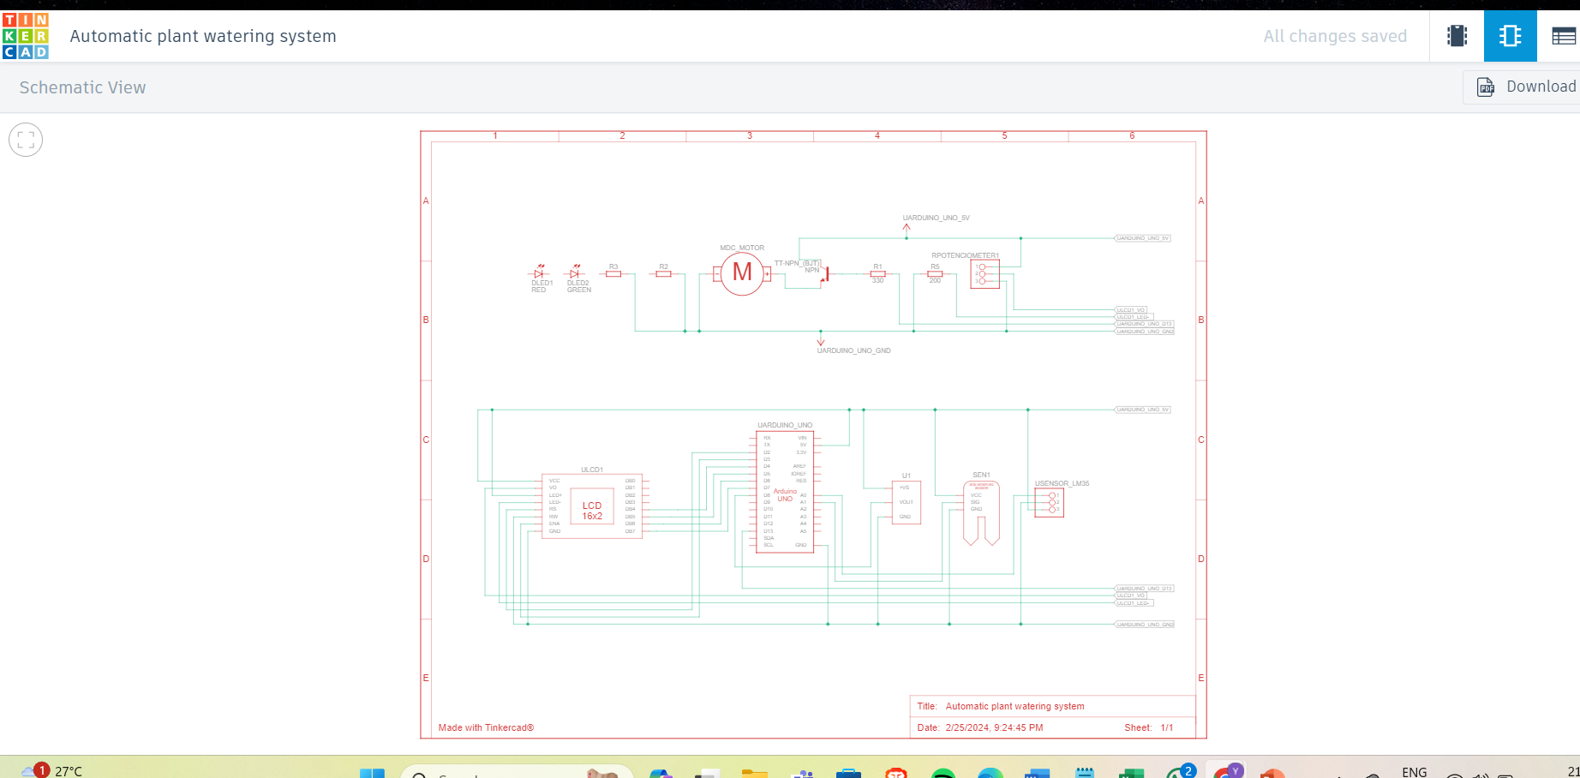

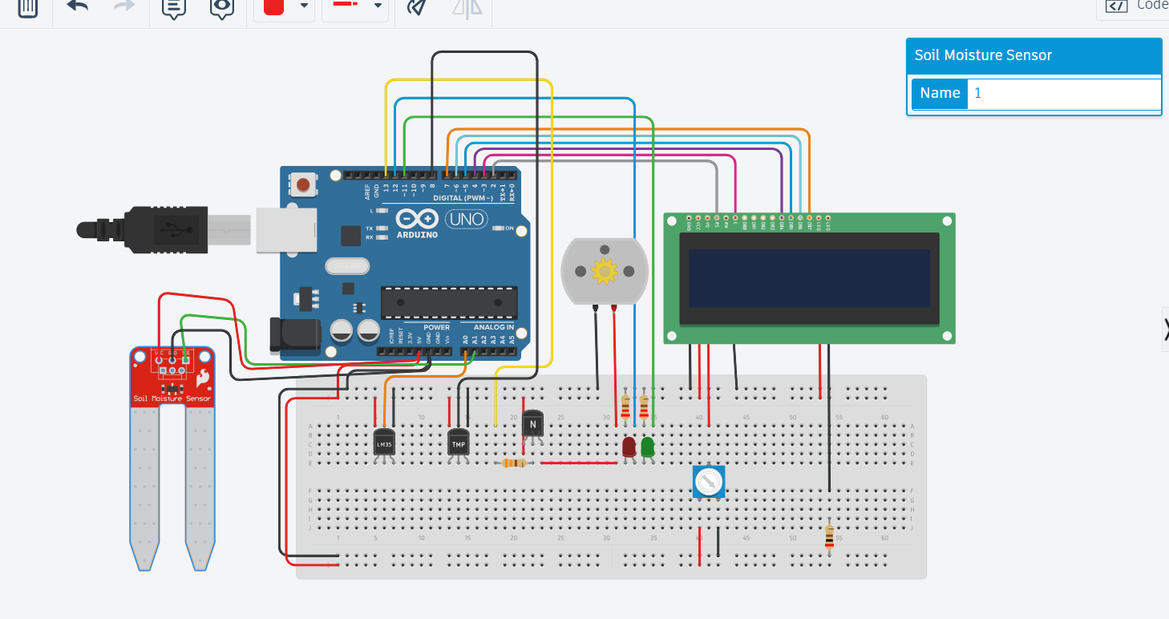

TINKERCAD

1. SOURCE CODE

#include <LiquidCrystal.h>

const int LM35 = A0;

const int moistureSensorPin = A1;

const int humiditySensorPin = A2;

const int motor = 13;

const int LedRed = 12;

const int LedGreen = 11;

LiquidCrystal lcd(2, 3, 4, 5, 6, 7);

void setup() {

Serial.begin(9600);

lcd.begin(16, 2);

lcd.print("Automated Plant");

lcd.setCursor(0,1);

lcd.print("Watering System!");

pinMode(motor, OUTPUT);

pinMode(LedRed, OUTPUT);

pinMode(LedGreen, OUTPUT);

delay(2000);

lcd.clear();

lcd.print("Temp= ");

lcd.setCursor(0,1);

lcd.print("WaterPump= ");

}

void loop() {

int value = analogRead(LM35);

float Temperature = value * 500.0 / 1023.0;

lcd.setCursor(6,0);

lcd.print(Temperature);

lcd.setCursor(11,1);

int soilMoisture = analogRead(moistureSensorPin);

int humidity = analogRead(humiditySensorPin);

float temperature = value * 600.0 / 1020.0;

if (Temperature > 50|| soilMoisture < 400|| humidity > 300 ){

digitalWrite(motor, HIGH);

digitalWrite(LedRed, HIGH);

digitalWrite(LedGreen, LOW);

lcd.print("ON ");

}

else {

digitalWrite(motor, LOW);

digitalWrite(LedRed, LOW);

digitalWrite(LedGreen, HIGH);

lcd.print("OFF");

}

delay(1000);

}

1. RESULTS AND DISCUSSIONS

From this work, we can control the moisture content of the soil of cultivated land. According to soil moisture, water pumping motor turned on or off via the relay automatically. This saves water, while the water level can be obtained in a preferred aspect of the plant, thereby increasing productivity of crops. Servo motor from vegetation water uniformly dispersed in water, in order to ensure the maximum utilization of absorption through. Thus, there is minimal waste of water. The system also allows the delivery to the plant when needed based on the type of plant, soil moisture, and observed temperature. The proposed work minimize the efforts of major agricultural regions. Many aspects of the system can be customized and used software to fine-tune the requirements of the plant. The result is a scalable, supporting technology. Using this sensor, we can see that the soil is wet or dry. If it is dry, the motor will automatically start pumping water.

1. CONCLUSIONS

Automatic system using a microcontroller, moisture sensor and other electronic tools were been developed. It was observed that the proposed methodology controls the moisture content of the soil of cultivated land. The motor automatically start pumping water if the soil is dry and need water and stops when the moisture content of the soil is maintained as required.

*REFERENCES*

*[1] S. V. Devika, SK. Khamuruddeen et aI., "Arduino based automated plant watering system" in International Journal of Advanced Research in Computer Science and Software Engineering, Volume 4, Issue 10, October 2014.*

*[2] Jonathan Gana Kolo, "Design and Construction of an Automatic Power Changeover Switch" in AU Journal of Technology, 11(2): (Oct. 2007).*

*[3] S. Darshna et aI., "Smart Irrigation System" in IOSR Journal of Electronics and Communication Engineering (IOSR JECE), Volume 10, Issue 3, Ver. II (May -Jun.2015).*

*[4] Jesper Sandberg and Thomas Kockholm, ''iPlant: Inteligent Plant System", in SPCL-2012 - Report.*

*[5] Vinay Bakale and SiddheshTolakar,"Wireless*

*Automatic Plant Irrigation System", International Journal on Recent Technologies in Mechanical and Electrical Engineering.*

*[6] Sanju kumar, and R.V. Krishnaiah, "Advance Technique for Soil Moisture Content Based Automatic Motor Pumping for Agriculture Land Purpose". International Journal of VLSI and Embedded Systems-IJVES, Vol 04, Article 09149; September 2013, pp 59*